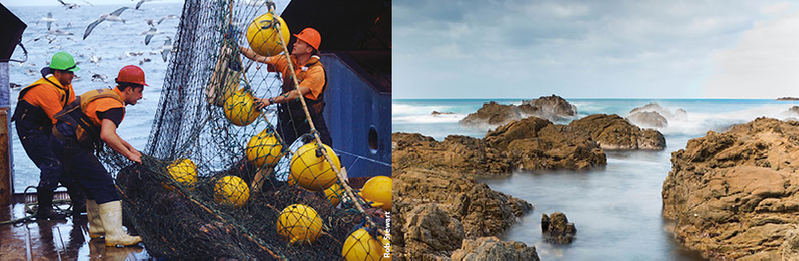

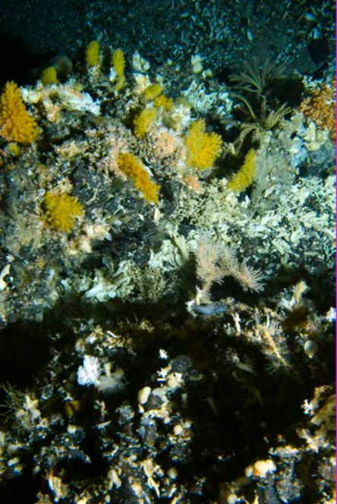

Request for Proposals
Sustainable Seas National Science Challenge
Innovation Fund

Contents
1. Innovation Fund 3
2. Key information for Applicants 3
2.1 Duration and Value of projects 3
3. Application process and timeline 3
4. Scope of call 4
4.1 Proposals that will contribute significantly to the Challenge meeting the Objective of the Challenge 4
4.2 Proposals that specifically address Project 2.2.2 in the Research Plan 4
4.3 What will not be funded through the Innovation Fund 5
5. Assessment criteria 5
6. Assessment Process 5

Innovation Fund
The purpose of the Challenge Innovation Fund is to introduce new innovative approaches, capability, research and researchers to the Challenge. There will be two calls for the Innovation Fund, one in March 2016 and a second in early 2017.

Key information for Applicants
This request for proposals covers the first call for proposals for the Sustainable Seas Innovation Fund. The closing date for the first round of submissions is 26 April 2016. Proposals must be submitted on the template to sustainableseasNC@niwa.co.nz by noon on this date. Late proposals will not be accepted.

Duration and Value of projects

Funding available | $1.5M (ex GST) per year for 2 years
Expected value per project | Maximum of $150,000 per year for 2 years.
Project duration | Up to 2 years
Project start date | 1 October 2016
Project completion date | By 30 September 2018
Eligibility | Open to all New Zealand based researchers*
*With the exception of researchers who are currently Programme Leaders or Project Leaders within the Challenge.

Application process and timeline
This call will be a two stage process. The initial expression of interest is to be a maximum of two pages, and will be evaluated by the Challenge Science Leadership Team. This will be followed by an invitation to successful parties to submit detailed proposals.
The template for the Expressions of Interest is available on the Sustainable Seas website and here.
The template for the detailed proposals will be made available to successful parties.
Expression of interest due | noon 26/4/2016
Notification of results and invitation to submit detailed proposals | 19/5/2016
Full and detailed proposals due | 27/6/2016
Successful proposals notified | 15/8/2016

Scope of call
This call is in two sections. The first section relates to an open call for innovative funding ideas with line-of-sight to the Challenge Objective; the second relates specifically to innovative funding ideas within the Valued Seas Programme, Project 2.2.2.

Proposals that will contribute significantly to the Challenge meeting the Objective of the Challenge
Proposals are sought that will contribute significantly to the Challenge meeting its Objective: “Enhance utilisation of our marine resources within environmental and biological constraints” and will complement the research already funded or planned within the Challenge. These projects are outlined in the Research Plan and full proposals of those currently funded are available here.

Successful proposals will have the following characteristics:
- A clear and direct contribution to meeting the Challenge Objective
- Complementary to currently funded projects in Challenge
- Innovative, high quality research.

Areas of interest include but are not limited to:
- Techniques for testing the efficacy of ecosystem based management tools and monitoring
- Techniques for mapping and modelling spatial and temporal usage of the marine estate by marine mammals or birds
- Methods and mechanisms for integrated mana whenua, industry and community stewardship initiatives for marine management
- Mātauranga Māori inspired innovation in effective marine management and / or utilisation
- Soft bottom habitat formation and stability.
- Population and ecosystem connectivity of deep-shelf benthic communities
- Use of currently available datasets or integration of currently available datasets to test hypotheses related to Challenge objectives.
This list is not exhaustive and other innovative ideas are encouraged. No specific weighting will be accredited to these topics over and above other innovative proposals.

Proposals that specifically address Project 2.2.2 in the Research Plan
Proposals are also requested that specifically address Project 2.2.2 in the Research Plan “Methods to increase diversification in marine economies” and address how we can add value to the marine economy.
Successful proposals will have the following characteristics:
- A clear and direct contribution to meeting the Challenge Objective
- Adding value to the marine economy
- Innovative, high quality research
- Aligned or co funding.

Areas of interest include but are not limited to:
- Reducing environmental stress in marine ecosystems
- Enhancing diversification of the economy from marine industry (current and future)
- Develop synergies between land-based activities / industry, coastal environmental remediation and potential genesis of new marine commercialisation prospects, including new energy sources
- Contribute to fast track harnessing of international research and / or bioinformatics to value add existing marine industry products, ideally also reducing waste flow and environmental burden.
- Identify how existing and new marine resources, including waste by-products, can be value added to create new wealth in an industrial ecology framework
- Identify new commercial ventures for application in remote and regional New Zealand, ideally harnessing interest and support for and from Māori economic programs.
This list is not exhaustive and innovative ideas are encouraged. No specific weighting will be accredited to these topics over and above other innovative proposals.

What will not be funded through the Innovation Fund
- Research that aims to identify, quantify or map economic marine resources
- Research that repeats research conducted in other areas
- Education and outreach activities

Assessment criteria
The Expressions of Interest and full proposals will be assessed against two primary criteria.
            - Benefit to the Challenge
              - Contribution to meeting the Challenge Objective
              - Co or aligned funding associated with the proposal
            - Research quality and innovation
              - Research clearly articulated, focussed and achievable
              - Research technically rigorous and consistent with best practice
              - Research is innovative and will bring new capability/capacity to the Challenge

Assessment Process
Proposals will be assessed by the Science Leadership Team with external advice from the Independent Science Panel and the Kāhui of the Challenge, and other experts as required.
In the case of the proposals associated with project 2.2.2, expertise will include a specially convened assessment panel.

All original phase 1 expressions of interest will be held confidential and destroyed if not transitioning to Phase 2
These were determined to be out of scope of the Challenge in the early stages of development of the Research Plan
For projects associated with Project 2.2.2

